**MOD 007045**

**Sustainable Land management**

**Element 010**

Ecological impact assessment of housing development at Cherry Hinton Chalk Pits

Module Leader – Dr Olivia Norfolk

To be handed in via Turnitin by 14.00 on 24th March 2021

Max of 1500 words

**Assignment brief**

This assignment makes up 50% of your final module mark. It requires you to produce an **Ecological Impact Assessment (EcIA)** for a hypothetical development project in Cherry Hinton Chalk Pits.

Firstly, your report should establish the current ecological value of the site, reporting the results from your desk-based scope and Phase-1 Habitat survey. You should focus on identifying species and habitats that are protected by national or international environmental legislation.

Secondly, you should discuss the ecological impact of building a housing development on this site. You should use scientific literature to assess which species, habitats and ecosystem processes are likely to be affected by the development process.

Lastly, you should identify gaps in the current ecological information available for the site and recommend protocols for additional surveys.

**The Scenario**

Cambridge is experiencing an extreme housing shortage and the Council are under pressure to meet Government targets for housing expansion in East Anglia. The Council have been looking for suitable locations for housing developments and have identified the old chalk pits in Cherry Hinton as a potential development site. Figure 1 shows the outline of the proposed housing development which will contain 150 new homes. It is your job to establish the ecological importance of the site in its current state and evaluate which species, habitats and ecosystem services will be impacted by the proposed development.

*The development site – Cherry Hinton Chalk Pits*

These two chalk quarries once provided hard chalk to build Cambridge University colleges and lime for cement. Quarrying finished in Lime Kiln Close approximately 200 years ago. Nature has reclaimed the site and woodland has developed. The Cherry trees that grow here are said to be descendants of the tress that gave Cherry Hinton its name. East Pit is the largest of the quarries and was worked up until the early 1980s. The site now consists of meadow surrounded by steep chalk cliffs.

The two pits are currently managed by the Wildlife Trust, but their close proximity to Cherry Hinton High Street and strong bus links to Cambridge City Centre make this a desirable location for a housing development.

*The proposed development*

A local entrepreneur has been in discussion with the Wildlife Trust about developing the site into an “eco-village” that will tackle the housing shortage, whilst trialling new, energy-efficient houses (remember this is hypothetical!). The new development would contain 150 eco-houses in the East Pit (Figure 1), all of which have solar panels, green-living walls and energy-efficient design. The proposal also includes a community farm and recreation area in Lime Kiln Close which aims to build self-sufficiency within the eco-village.

You have been employed as an ecological consultant to assess the ecological impact that a housing development would have on this site.

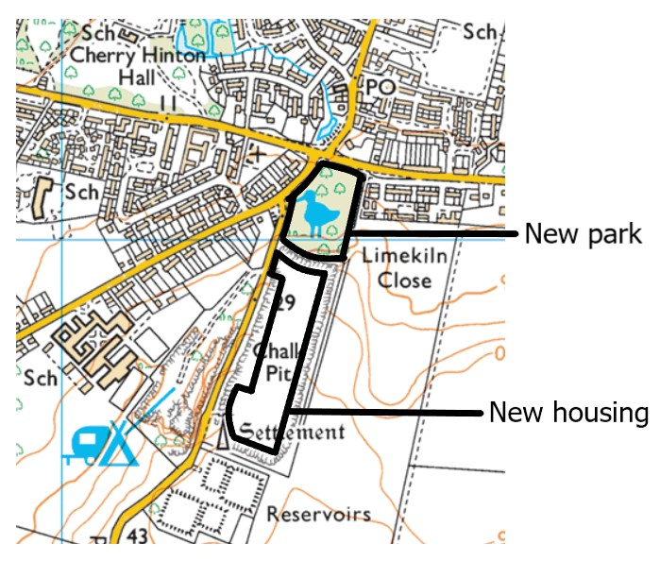

**Community farm and recreation area**

**150 eco-houses**

**Figure 1.** Proposed site of the eco-village at Cherry Hinton Pits.

.

**The assignment**

This assignment is worth 50% of your final module mark. It consists of three parts, each consisting of specific tasks which are listed below.

|  |  |  |
| --- | --- | --- |
|  | | Proportion of marks (within element) |
| **Part 1**  **The ecological value of the site** | | **40%** |
| Task 1 ☐ | Results from desk-based scope | 30% |
| Task 2 ☐ | Phase-1 habitat survey | 10% |

|  |  |  |
| --- | --- | --- |
| **Part 2**  **The ecological impact of the development** | | **50%** |
| Task 3 ☐ | Scoping matrix outlining potential impact | 20% |
| Task 4 ☐ | Scientific rationale for impacts | 30% |

|  |  |  |
| --- | --- | --- |
| **Part 3**  **Recommendations for further surveys 10%** | | |
| Task 5 ☐ | Protocols for additional surveys | 10% |

**Part 1: Establishing the ecological value of the Cherry Hinton Pits (40%)**

The role of an ecological consultant is to establish the ecological value of a potential development site and “scope” any issues that need to be raised with planning and decision-making authorities. This information is sought through a combination of field surveys and desk-based scopes of internet resources.

*Task 1: Desk-based scope (30%)*

Your first task is to conduct a desk-based scope of the Cherry Hinton Pits and the surrounding landscapes (2kmradius).You will need to examine existing records on websites such as NBN Atlas and MAGIC and identify any species, habitats or ecological features that you think the planning authorities should be made aware of. Refer back to the lecture on environmental legislation and make sure that you emphasise protected or endangered species and habitats with nature designations. You should also draw attention to natural features with an important ecological role, such as water-courses, flood plains or carbon storage.

We will cover the technical aspects of conducting a desk-based scope in the Week 3 live online session.

Top marks go to those who:

* Present their scope clearly and concisely.
* Identify protected and endangered species and habitats.
* Refer to relevant environmental legislation (Site designations, Birds Directive, IUCN Red List).
* Identify any natural features with a major role in ecosystem functioning.
* Label all tables and reference them in the text.

*Task 2: Phase-1 Habitat Survey (10%)*

A Phase-1 Habitat Survey is a standardised system for classifying and mapping wildlife and habitats across the UK. Habitat classifications are based on the dominant vegetation and/or land use type and do not require in-depth description of plant communities. This makes the system particularly suitable for initial surveys of large plots of land and it is regularly used by ecological consultants scoping development sites.

Your colleague, Emma Forest, conducted a Phase-1 Habitat survey of the site (on **15th March 2020)** in order to provide additional ecological information to supplement your desk-based scope. You have been provided with a map that distinguishes habitats to a resolution of 30mx30m and a list of target notes, which provide additional information about points of ecological interest, such as:

* Interesting management practices
* Small areas of habitats that cannot be mapped
* The composition of the plant community
* Evidence of rare or protected species (nests, burrows, footprints)
* Potential habitats for rare or protected species (e.g. veteran trees, fresh-water ponds).

As part of your Ecological Impact Assessment you should present the Phase-1 Habitat Survey Map and Target Notes (which are provided on Canvas) and provide summary text to describe the habitat types that were present. You should describe the relative extent of each habitat-type (measured as a percentage of the total area of the surveyed site).

You will need to make sure that your map is well-presented, cited in the text and accompanied by a colour-coded legend that identifies the habitat types present at the site.

Top marks will go to those who:

* Write a short summary paragraph including the relative extent of each habitat type (calculated as the % of the total area surveyed).
* Present the Phase-1 Habitat Map and associated Target Notes (provided on Canvas) in a professional format.
* Accompany the map with a colour-coded legend defining the JNCC Phase-1 habitat classifications.
* Include figure/table legends and ensure both are cited in text.

NOTE

To summarise the results from the habitat survey you should estimate the relative extent of the different habitat types as a percentage of the total area of the site. You could do this using GIS software (ArcGIS or QGIS), plotting the different habitat-types as polygons and then calculating their areas.

Alternatively, you could use an old-fashioned method known as a Romer grid to estimate the areas directly from your paper map. The Rommer grid is simply a grid of regularly spaced dots on transparent paper, which is placed over the map. Count the number of dots that fall within the site as a whole, and within each habitat type, and calculate the percentage. This will be explained in class.

**Part 2: Assessing the ecological impact of the proposed development (50%)**

Now that you have completed your initial surveys, you need to assess how the ecology of the site would be affected if the housing development were to go ahead. To do this, you will need to consult the scientific literature and think carefully about the local ecology and behaviour of different species groups.

*Task 3: Scoping Matrix (20%)*

Ecological consultants will often produce a “scoping matrix” which rates the impact that the development process will have on different elements of the environment.

They will consider how different stages of the construction process impact different ecological features. They can use a variety of scoring systems for rating the level of impact including numerical systems, colour-coding or simply high/medium/low.

You should use the information collected in Part 1 to produce your own scoping matrix for inclusion in your Ecological Impact Assessment. The matrix should list the sites important ecological features versus any aspects of the development that you think might threaten them. You should then rate the predicted ecological impact associated with each element as high, medium or low. See example below:

|  |  |  |  |  |  |
| --- | --- | --- | --- | --- | --- |
|  |  | *During Construction* |  | *After construction* |  |
|  | **Noise pollution** | **Increase of dust and waste** | **Street lights** | **Concrete paving** | \Etc. |
| Cherry Hinton Brook | *Low* | *High* | *Low* |  |  |
| Bats | *High* | *Medium* | *Medium* |  |  |
| Great-crested newt etc. |  |  |  |  |  |

When creating the matrix, consider ecological features from both your Phase-1 Habitat Survey and the desk-based scope of the wider vicinity (2km radius). Remember that factors such as noise or light pollution can indirectly influence species outside of the development site.

It is useful to split the development stages into pre- and post-construction, because the building process can pose different threats to the end result. See examples in lectures for more information.

Your scoping matrix should be clearly presented as a table with a heading and cited in the main text. You should rate the impacts of at least four developmental stages likely to threaten nature and your ecological features must correspond with Part 1 of the assignment.

*Task 4: Scientific rationale behind impacts (30%)*

The rating of impacts can be very subjective and is open to bias. To minimise this risk, you should take the time to consult the scientific literature and look at documented examples of how different species groups respond to the development process. Evidence will not always be available for specific species or habitats, but you can gain valuable insights from the available literature.

Your scoping matrix should be accompanied by text that explains the scientific rationale behind your impact ratings.

Top marks will go to those who:

* Provide strong justification of their impact ratings
* Back up explanations with relevant scientific evidence.
* Cite and reference literature in accordance with scientific standards.

**Note:**

Unfortunately, the field of ecological consultancy is not entirely evidence-based and you will struggle to find specific examples for all of the species and taxa that you have identified on the site. You will not be penalised for this, but will be awarded marks for thinking creatively and finding relevant research that backs up your justifications.

The categories that you choose to include within your scoping matrix may also be influenced by the quality and type of evidence that you can find in the literature, i.e. you may choose to list well-studied species individually in your matrix (e.g. great-crested newt), whilst pooling others by taxa (e.g. hedgerows, freshwater invertebrates etc).

**Part 3. Recommend additional surveys (10%)**

*Task 5: Protocols for additional surveys (10%)*

After the initial scope and impact assessment, an ecological consultant will normally advise that additional surveys are carried out. A thorough Ecological Impact Assessment should report on six species groups:

1) Trees/woodland

2) Hedgerows

3) Water bodies

4) Mammals

5) Birds

6) Amphibians and Reptiles

Look at the above list and decide whether your current scope provides sufficient information about any/all of these groups. If it does not, then you should recommend additional surveys. You will need to read relevant guidelines about surveying techniques and recommend suitable sampling protocols for the under-represented groups.

Be selective about which groups require further surveys. Some taxa may already have sufficient data available (e.g. from existing species records), whilst other groups could be entirely absent or of little conservation concern.

To get top marks you should:

* Identify data-deficient groups for further surveys.
* Prioritise surveys of threatened or protected species or taxa.
* Provide advice about appropriate survey protocols (consider what equipment should be used, the number of replicates, time of day and season).
* Include citations and references for survey protocols.

Note.

Links to recommended survey protocols can be found on Canvas

**The combined document should be submitted via Turnitin by 14.00 on 24th March 2021.**

**Sources of Information**

**Some useful References**

JNCC Handbook for Phase 1 habitat survey (2010). A technique for environnemental audit. Nature Conservancy Council/JNCC

Damant, S. & Warrington, S. (2006) A flower in the desert: The rich wildlife of the

Wimpole Estate, Cambridgeshire. British Wildlife 17: 324 - 300.

**Online resources to be used in desk-based scope:**

MAGIC website - <http://www.natureonthemap.naturalengland.org.uk/>

National Biodiversity Network (NBN) atlas - <https://nbnatlas.org/>

**Other useful websites :**

<http://www.cperc.org.uk/> website for the Cambridgeshire & Peterborough environmental records centre

You can find example EIAs of real developments on google, but you can also found generic guidance and guidelines on the following websites:

<http://www.cieem.net/>

<http://www.snh.gov.uk/planning-and-development/environmental-assessment/>